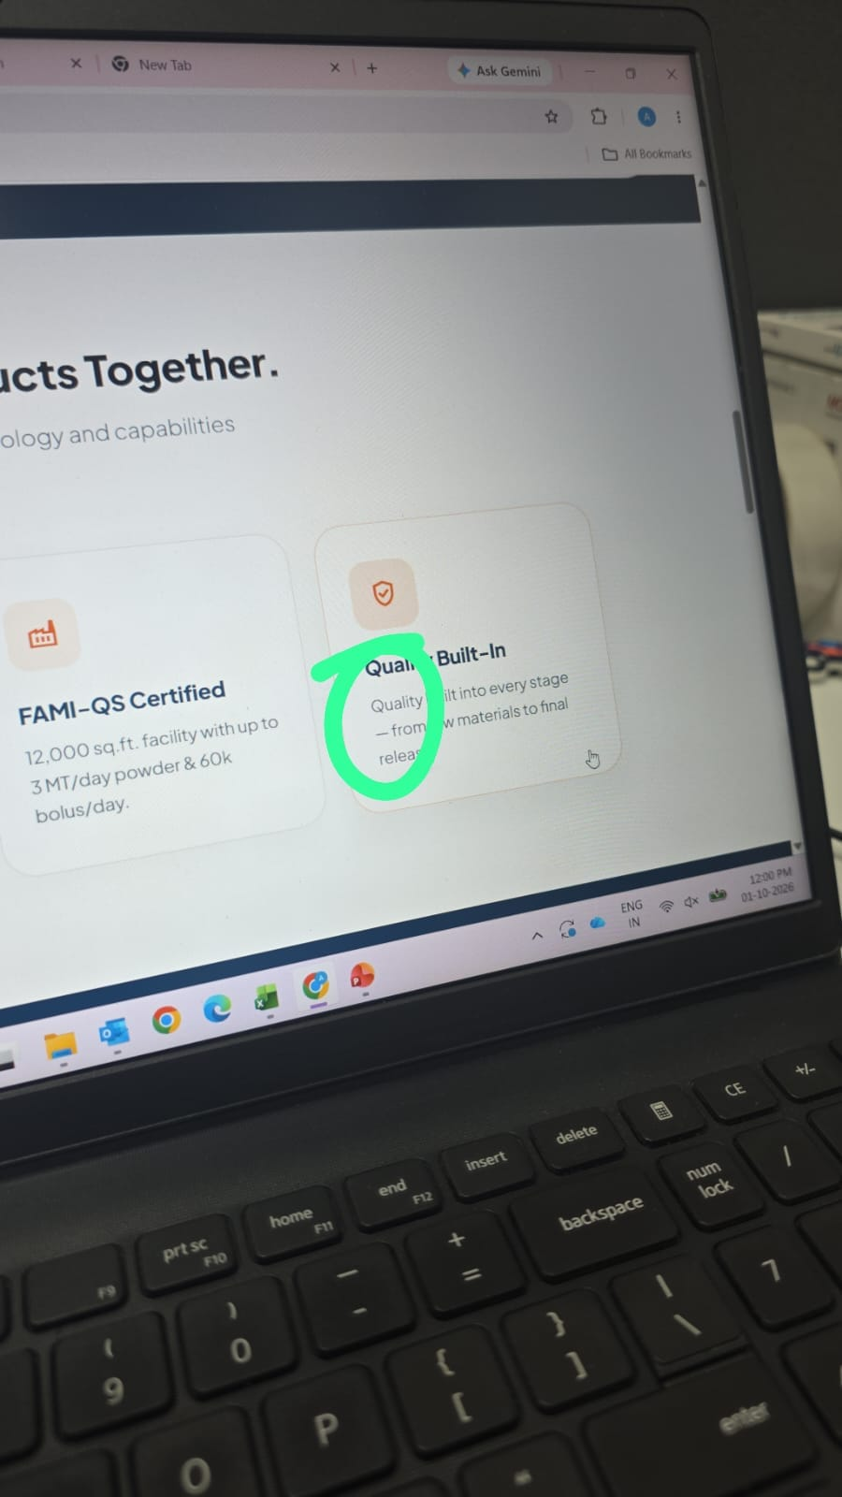
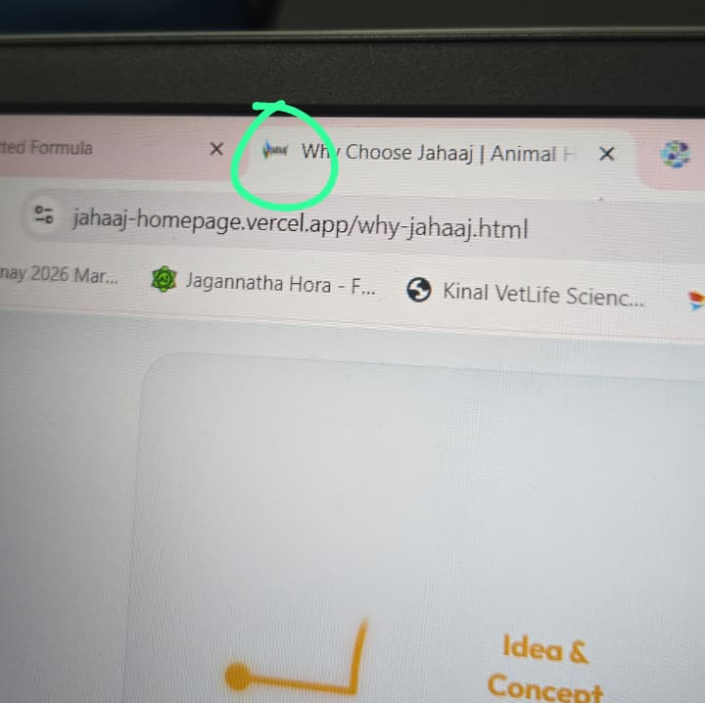
WEBSITE CORRECTIONS:

- Add jahaaj logo on the browser tab logo 2. Change the size of the hypen (-)
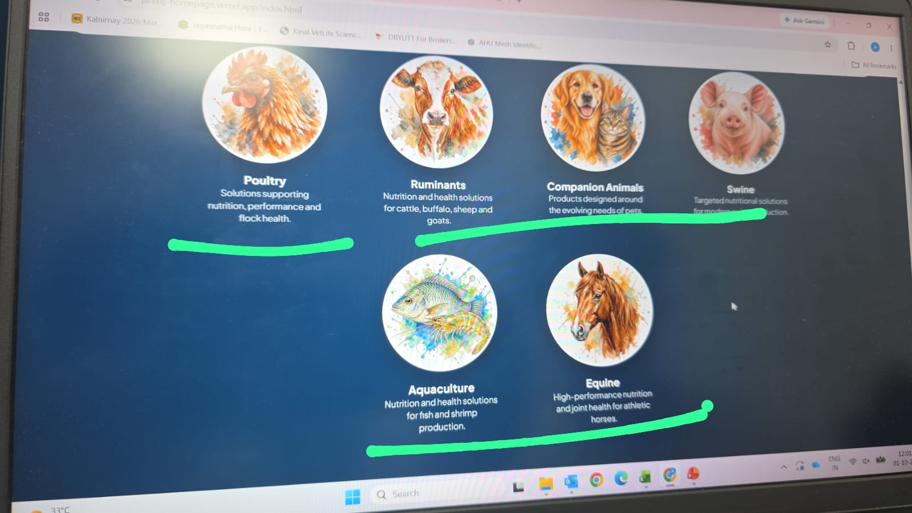
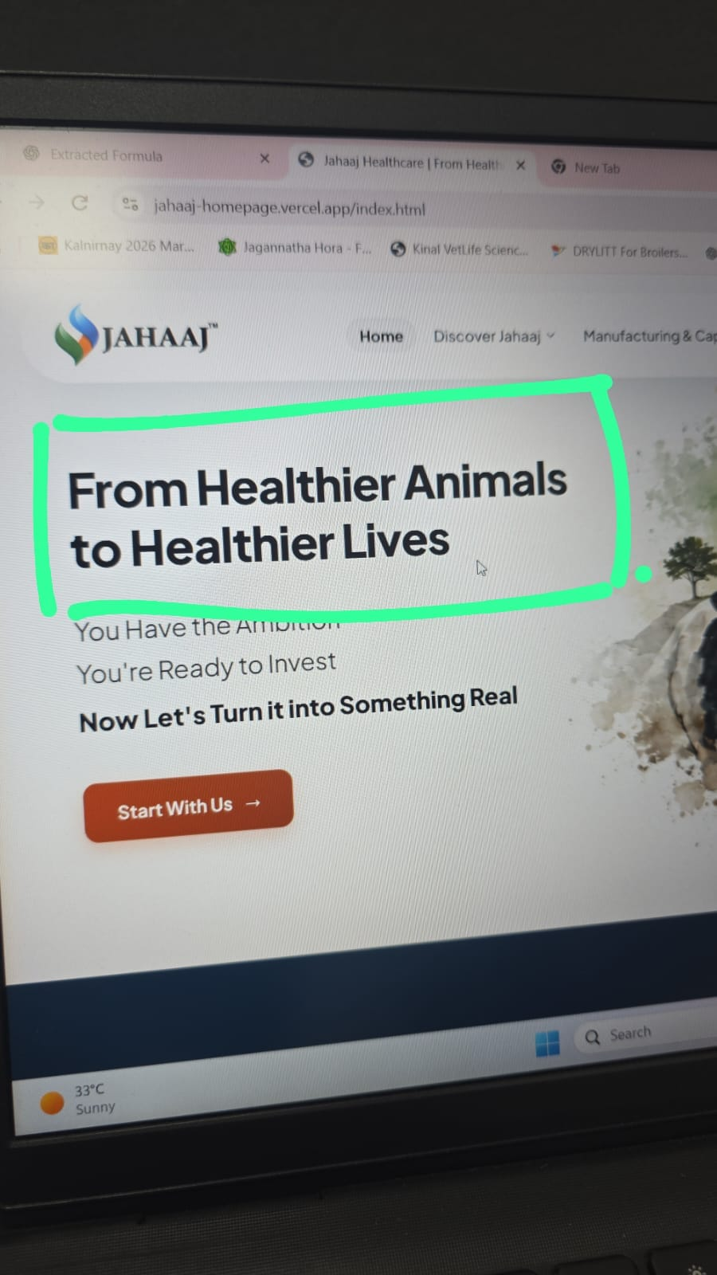

3.remove the content from the 6 animal categories. 4. Change the font of the heading
only names required

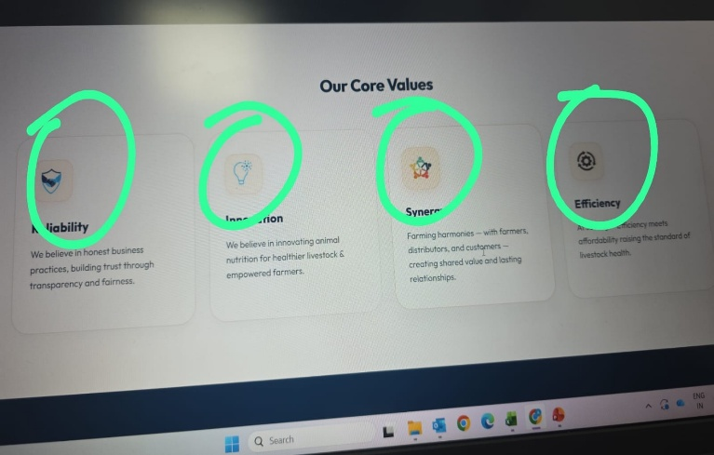
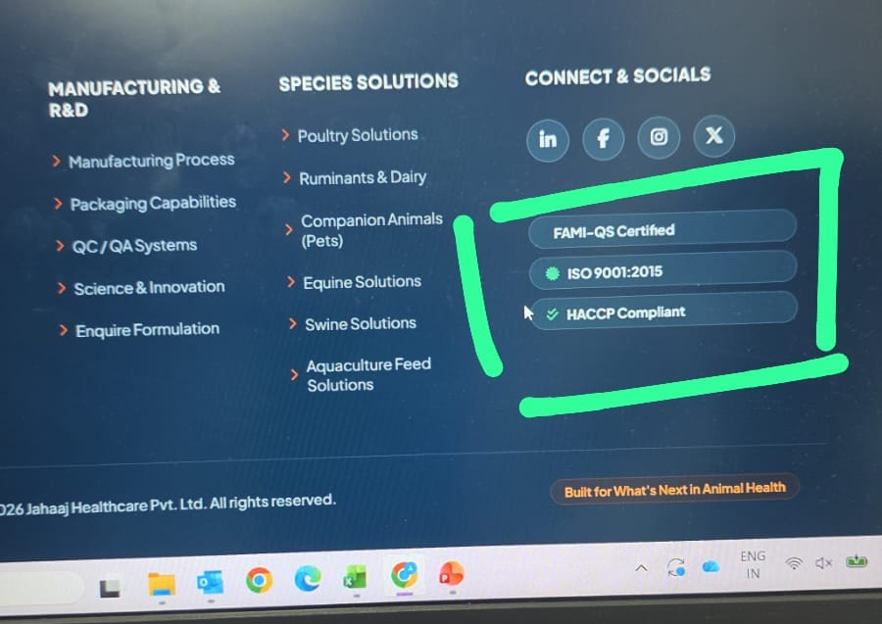

5. remove the marked part from footer also align the 6. Make the icons bigger
rest sections of the footer properly in same line.
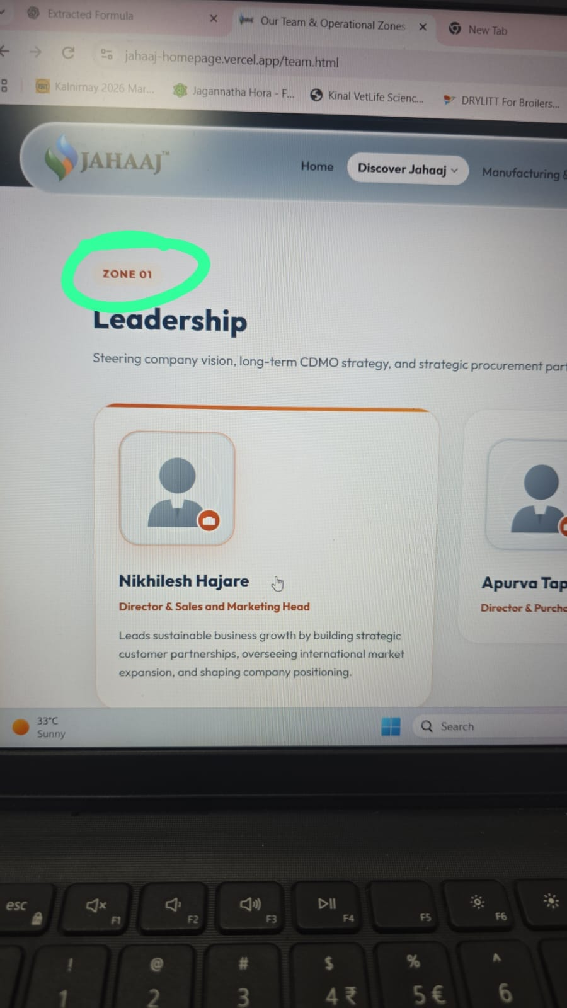
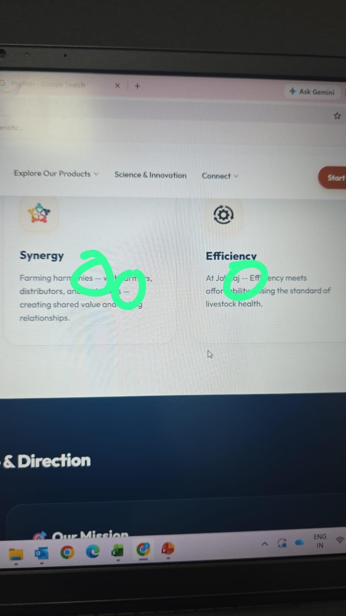

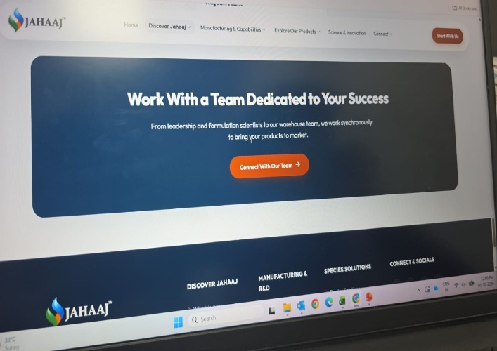
7. Change the size of the hypen. 8. Remove the zones from our team section.
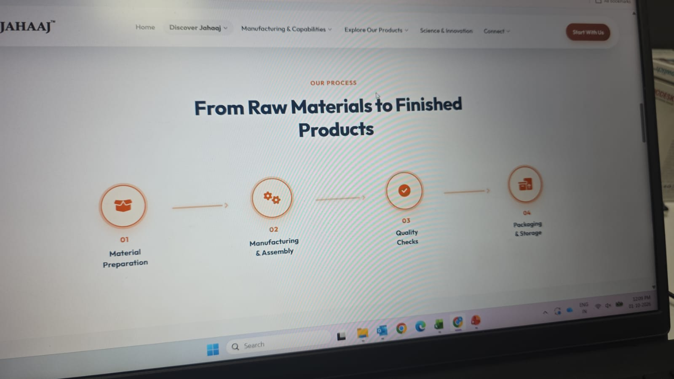

Remove this CTA part from our team section Remove this part

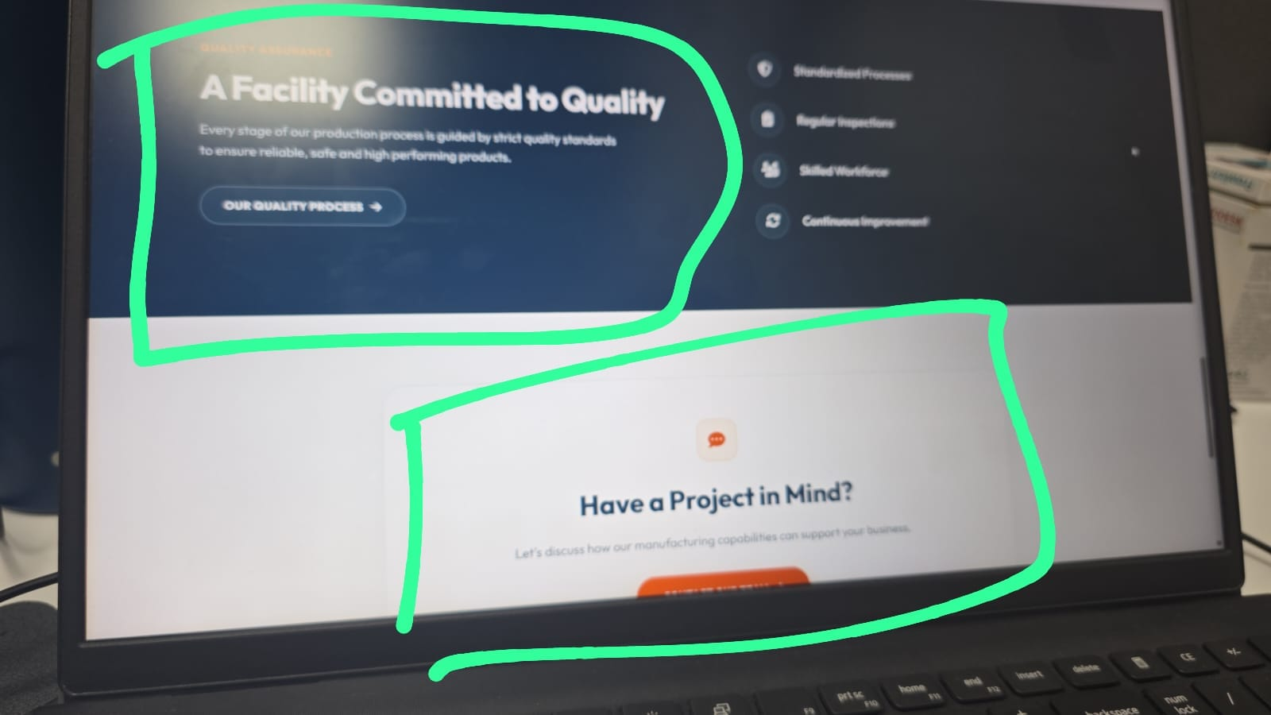
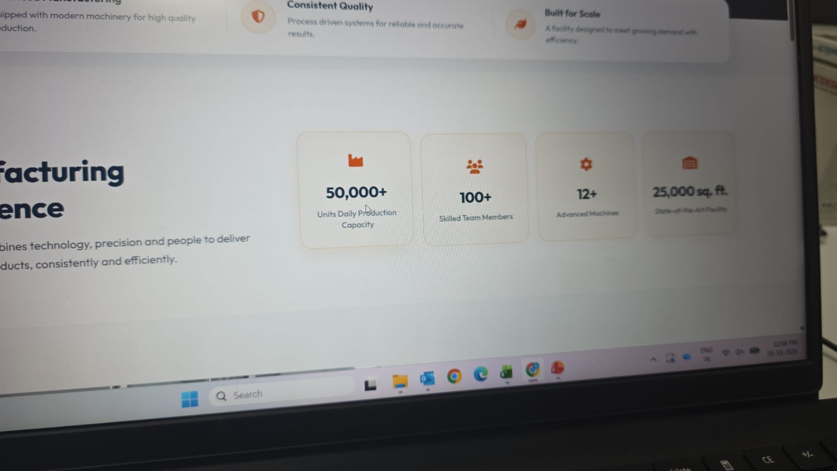

change these 4 cards: Remove the whole part (both) from the section
1. Bolus and tablet manufacturing
50k-60k units/
2. Powder manufacturing
3MT/day
3.liquid
3500 L/day
4. 12,000 sq. ft.
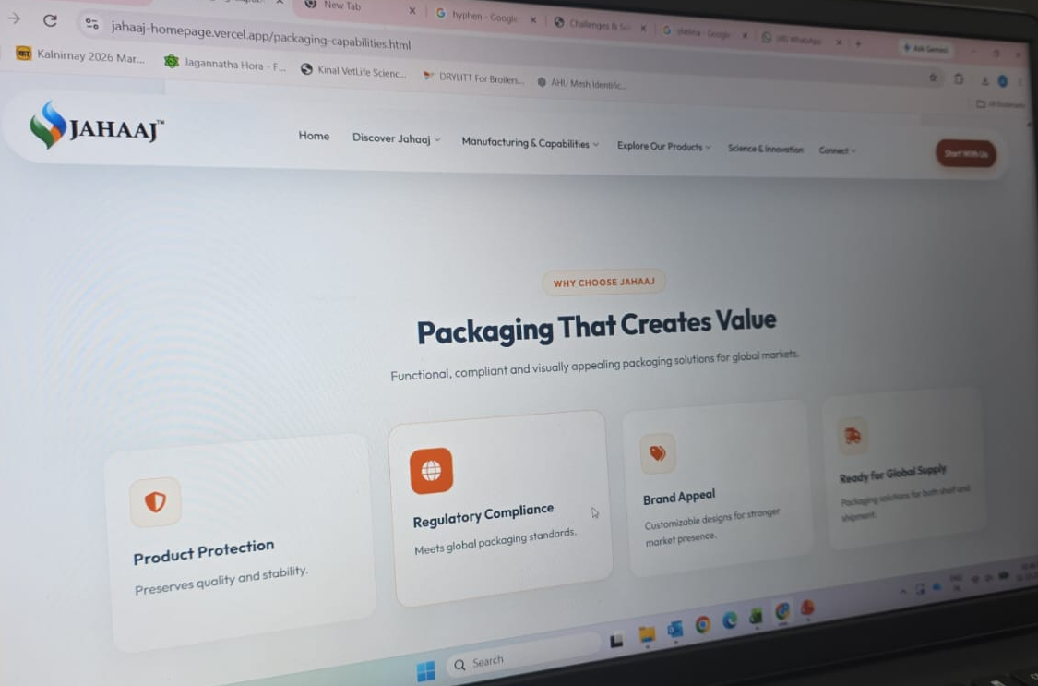
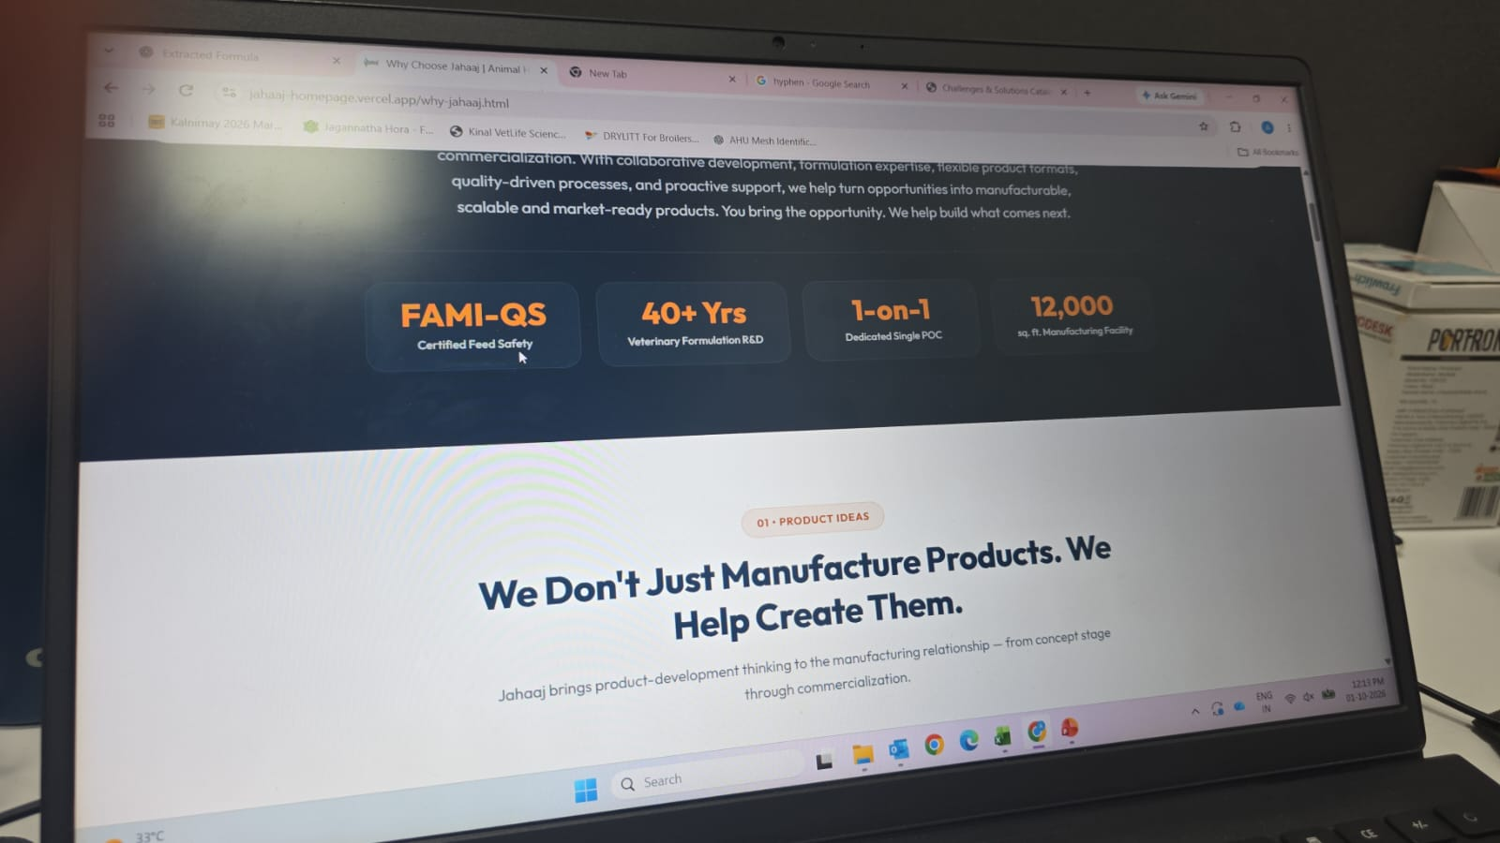

ADD a sentence some thing like: Remove this part from the section
7 reasons to work with us (after hero section)
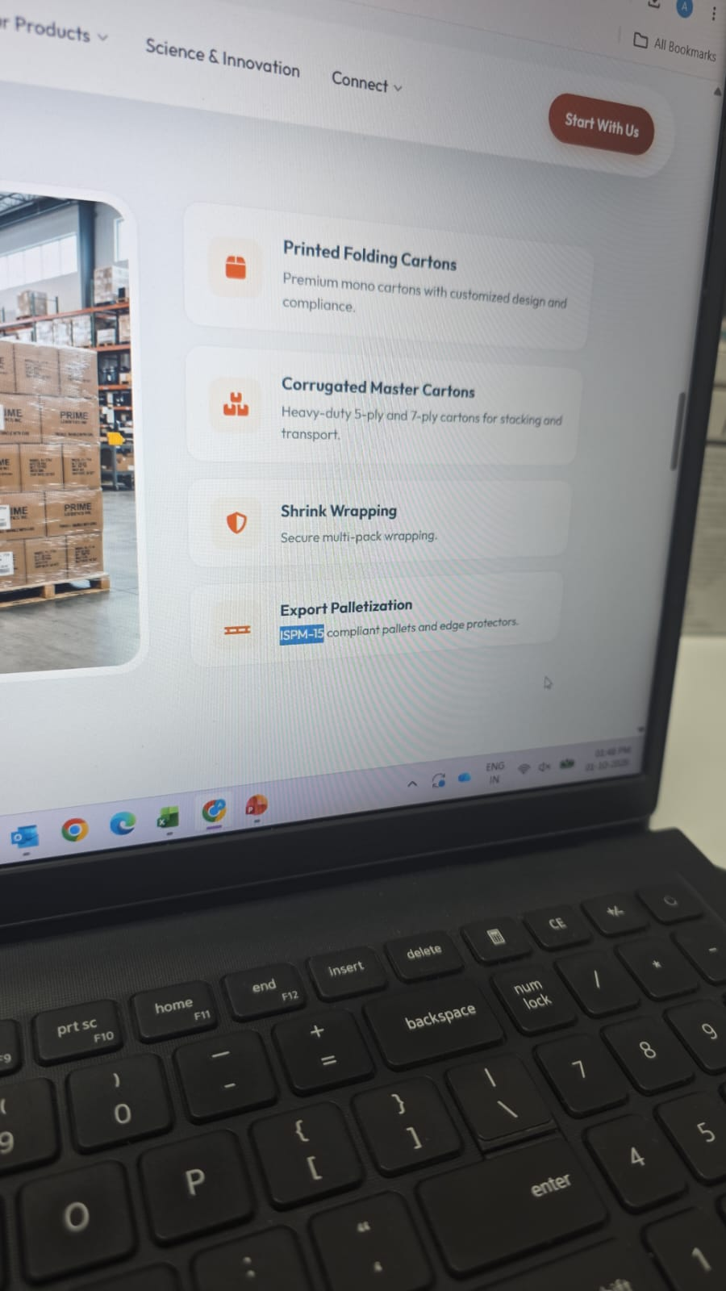
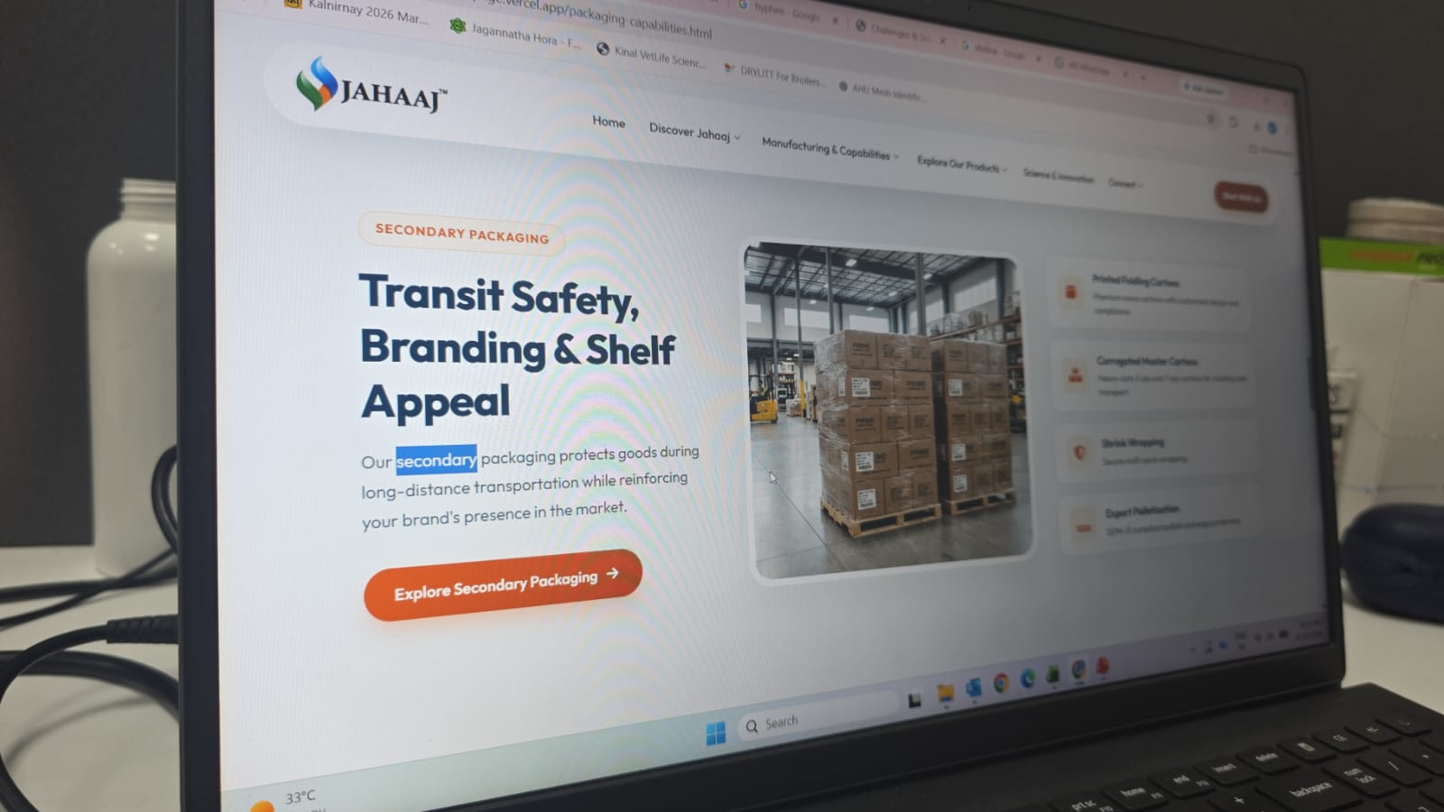

Correct the highlighted part as: Remove the highlighted part and add “ Export
secondary and tertiary packaging compliant pallet”
also remove the CTA: explore secondary packaging

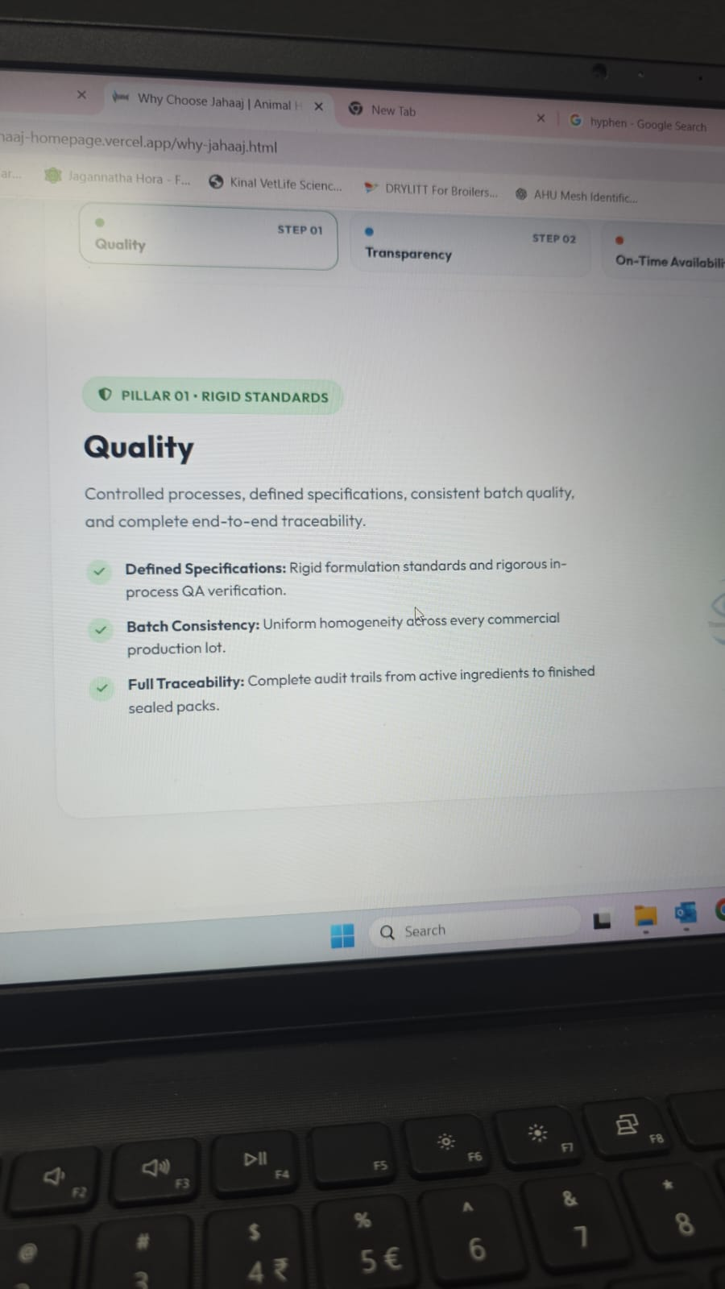

Remove the text after “Quality”
and change the 3 points as:
Clear Specifications: Every product follows defined standards and quality checks.
Consistent Batches: Every batch is made with the same quality and uniformity.
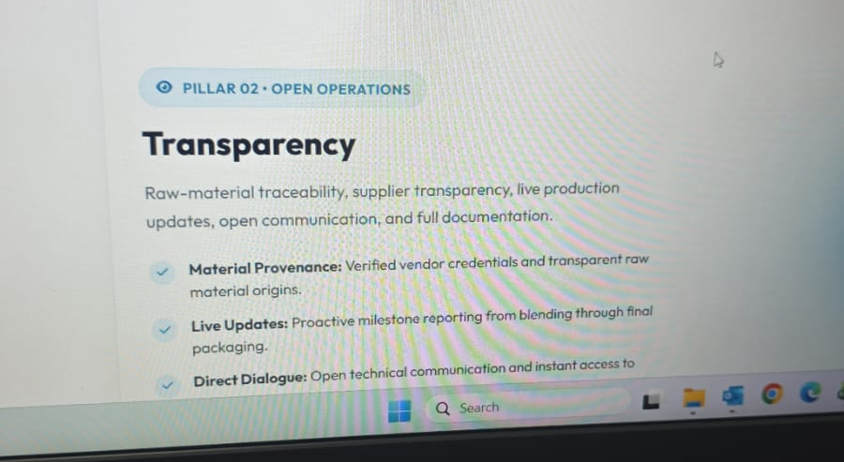
Complete Traceability: Every ingredient and finished product can be tracked from start to finish.

Remove the text after “Transparency”
and change the 3 points as:
Material Transparency: Clear information about raw materials and suppliers.
Live Updates: Regular updates throughout the production process.
Open Communication: Easy access to technical information and batch documents.

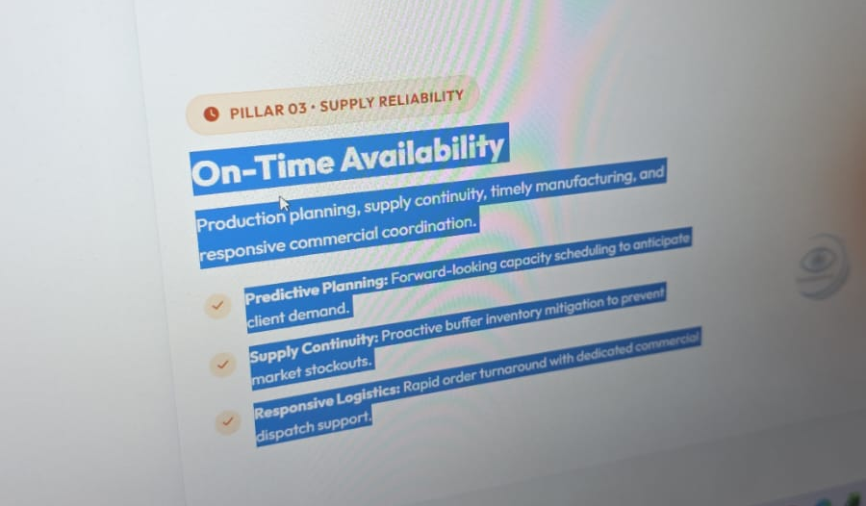
Remove the text after “On-Time Availability”
and change the 3 points as:
Planned Production: Production is planned in advance to meet customer demand.
Reliable Supply: We maintain supply continuity to avoid stock shortages.
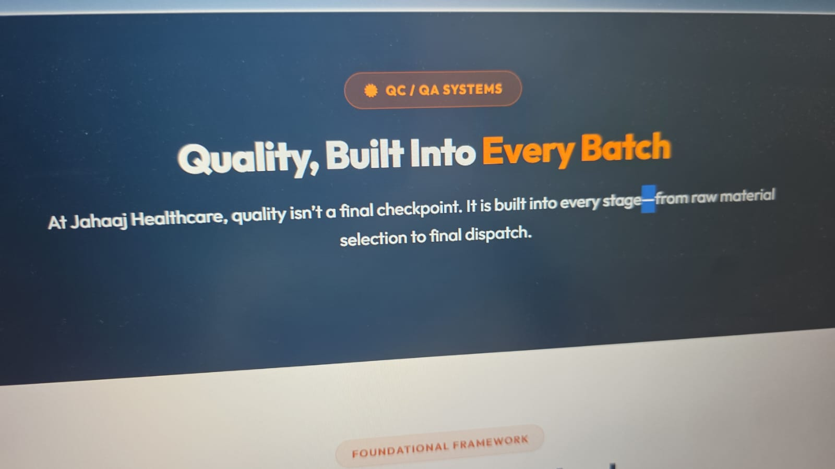
Timely Delivery: Fast order processing and dispatch with responsive coordination.
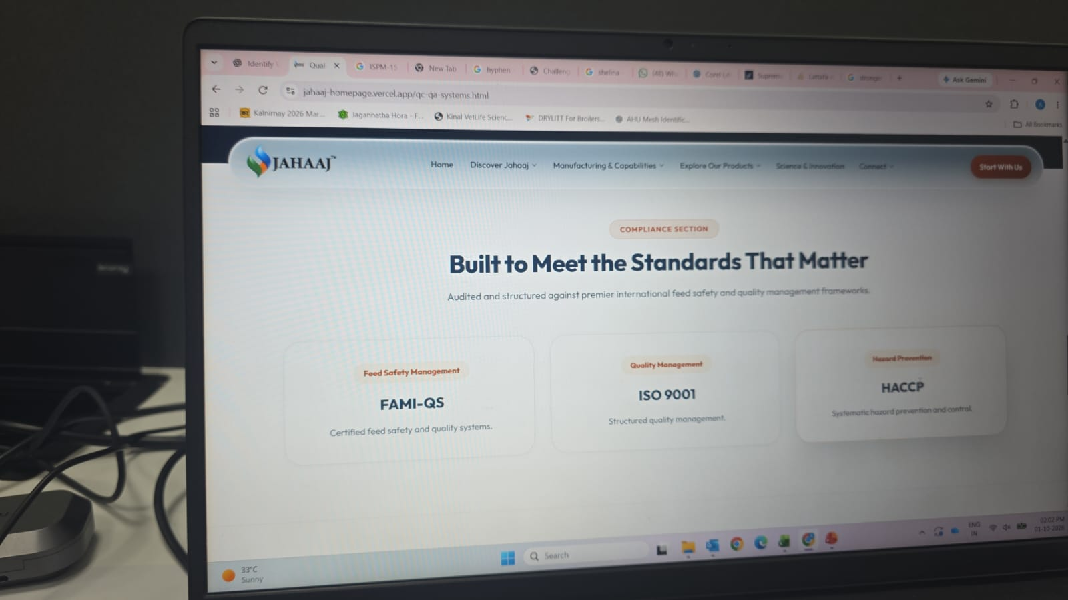

Change the hypen size (-) Remove the cards and add famiqs certificate in
this part (attached with the mail)

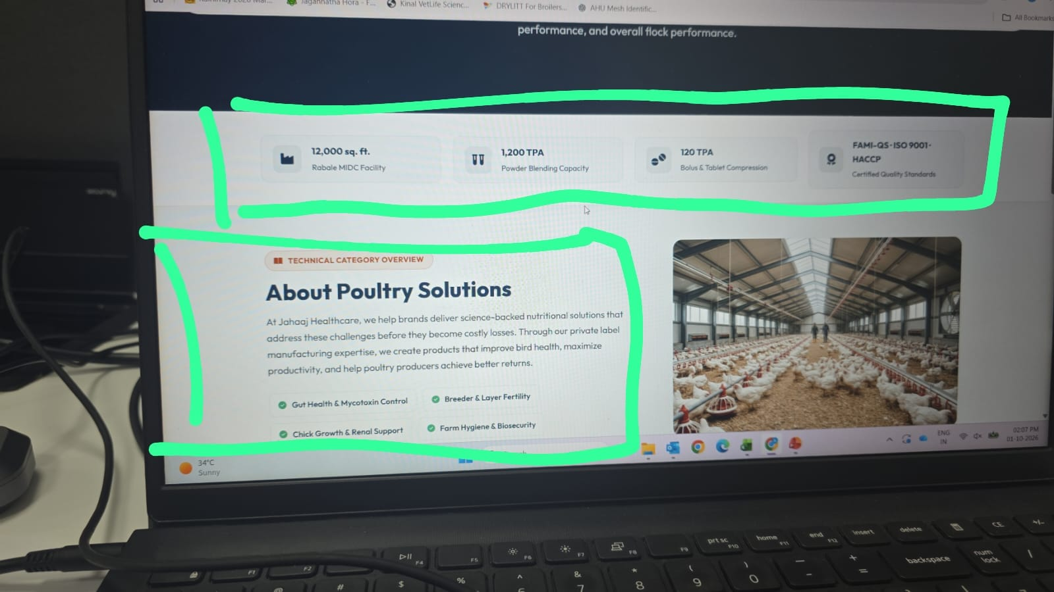

Remove the marked part from the section, also place the image on the hero section on the right side of the page.
similarly do this for all the categories( ruminants, pet, swine, equine, aqua)

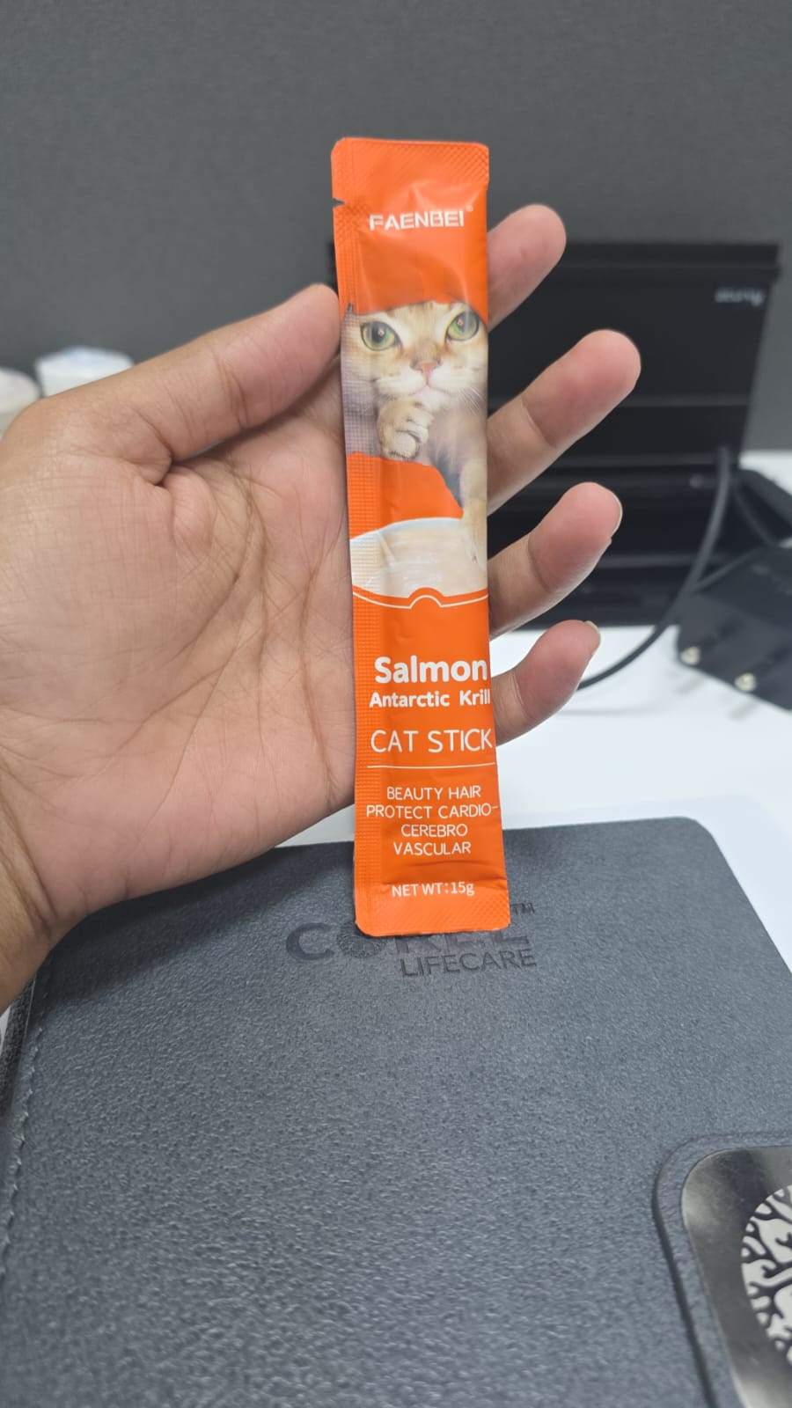

Note: add this kind of vertical sachet sticks (plain) in the packaging section (in the sachet section of packaging and capabilities)
also add photos of the following in the packaging sections:
foils (along with blisters), cartons, monocartons, 25 kg bags

Note:
In the jahaaj photos section:
follow this order
1. Jahaaj building exterior
2.Raw material receiving area
3. Production passage area
4. Raw material storage
5. QC chemical lab
6. Granulation department
7.Compression machine
8. Powder mixing department
9. QC Instrument room
10. Microbiology lab
11. PET AHU
12. Packaging department (first floor)
13. Passage area (first floor)
14. Packaging area (ground floor)
15. finished good storage

